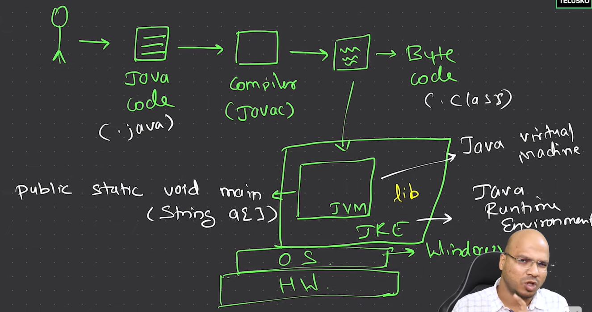

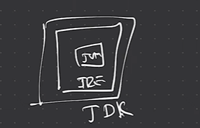

**>>** JVM does not look for just main method, it looks for entire method signature “public static void main(String a[])”

**>>** Java is called WORA -> Write Once Run Anywhere

**>>** **JIT**: Just In Time Compiler: The Just-In-Time (JIT) compiler is a component of the runtime environment that improves the performance of Java™ applications by compiling bytecodes to native machine code at run time

**>> AOT**: Ahead Of Time Compiler: It used to compile byte code to native code prior to the execution by the JVM.

**>> Java Features:**

Simple, Secure, Portable, Object-Oriented, Robust, Multithreaded, Architechture-neutral, Interpreted, High performance, Distributed, Dynamic.

**Secure:** In java, we don’t have pointers, so we cannot access out-of-bound arrays i.e it shows **ArrayIndexOutOfBound Exception** if we try to do so. That’s why several security flaws like stack corruption or buffer overflow are impossible to exploit in Java. Also, java programs run in an environment that is independent of the os environment which makes java programs more secure.

**Robust**: The main features of java that make it robust are garbage collection, Exception Handling, and memory allocation.

>> beginning with JDK 8 it is now possible to define a default implementation for a method specified by an interface. I f no implementation for a default method is created the the default defined by the interface is used.

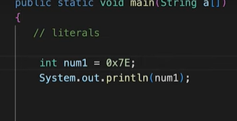

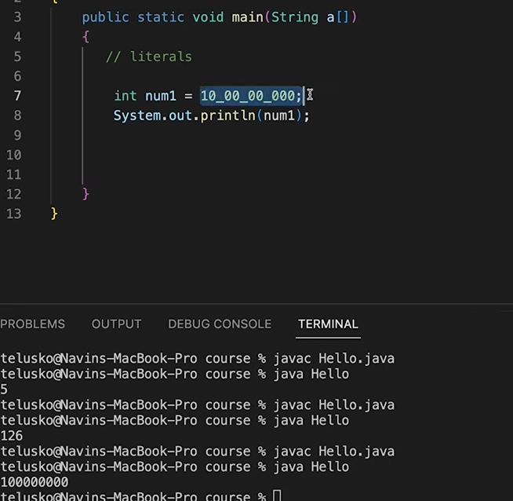

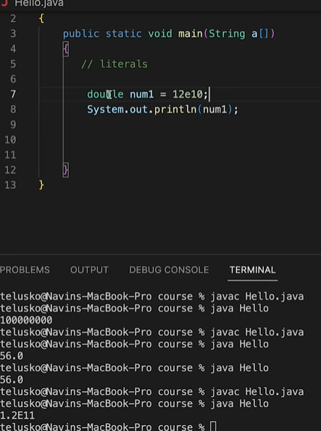

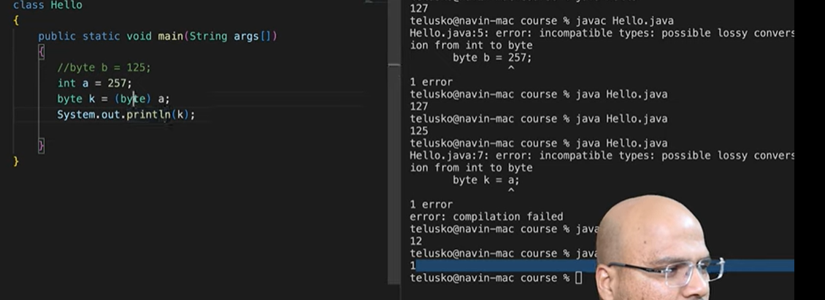

Here 257 is out of range so printing 257%256

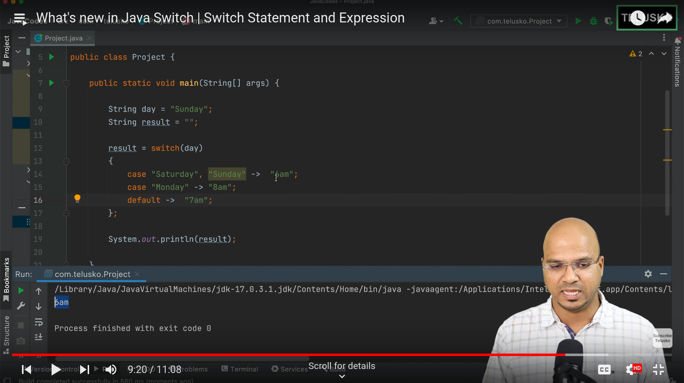

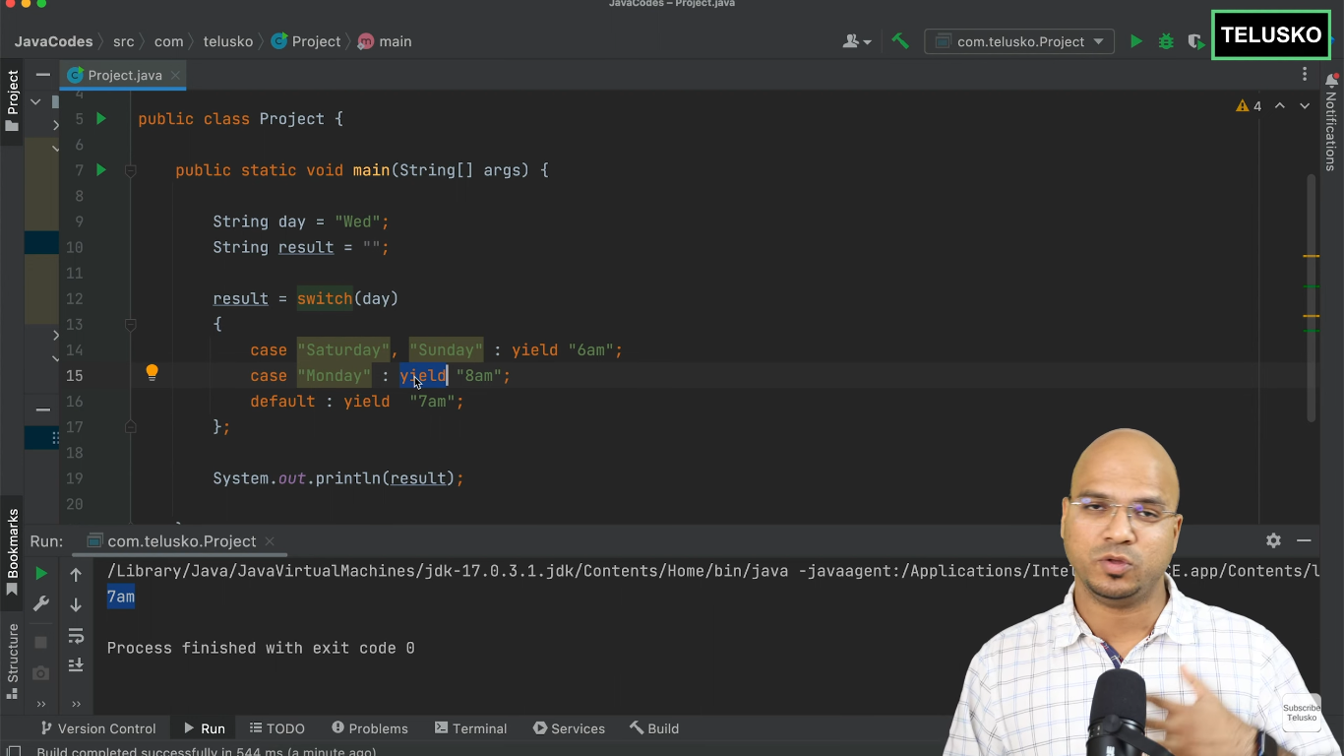

**>>**

**Car c = new Car(); Memory management in sequential order**

1. **Class Loading**:

- **Check if Class is Loaded**: The JVM checks if the `Car` class is already loaded. If not, the class loader loads it into memory.

- **Class Verification**: The JVM verifies the bytecode of the `Car` class for correctness and security.

- **Class Preparation**: The JVM allocates memory for static variables of the `Car` class and initializes them to default values.

- **Class Resolution**: The JVM resolves symbolic references in the `Car` class to actual references.

2. **Reference Variable Creation**:

- **Reference Variable Creation**: A reference variable `c` of type `Car` is declared. If `c` is a local variable, it is created on the stack. If it is an instance variable, it is part of the memory layout of the containing object, which resides on the heap.

3. **Object Creation**:

- **Memory Allocation**: The JVM allocates memory for a new `Car` object on the heap. The size of the allocated memory depends on the fields defined in the `Car` class.

- **Default Initialization**: The memory allocated for the `Car` object is initialized to default values (e.g., `0` for numeric types, `null` for reference types, `false` for boolean).

- **Constructor Call**: The constructor of the `Car` class is called, which may further initialize the fields of the `Car` object with specific values.

4. **Reference Assignment**:

- **Assign Memory Address**: The memory address of the newly created `Car` object is assigned to the reference variable `c`.

5. **Garbage Collection**:

- **Reachability Check**: The `Car` object remains in memory as long as it is reachable through the reference variable `c` or any other references.

- **Object Eligibility**: When the reference variable `c` goes out of scope or is assigned to another object or `null`, the `Car` object becomes eligible for garbage collection.

- **Garbage Collection Process**: The garbage collector eventually reclaims the memory used by the `Car` object, making it available for future allocations.

So the correct order is:

1. Class loading (if needed)

2. Reference variable creation (`c` on the stack)

3. Object creation (memory allocation on the heap)

4. Reference assignment (heap address assigned to `c`)

5. Garbage collection (if applicable)

This revised sequence correctly reflects how the JVM manages memory when the statement `Car c = new Car();` is executed.

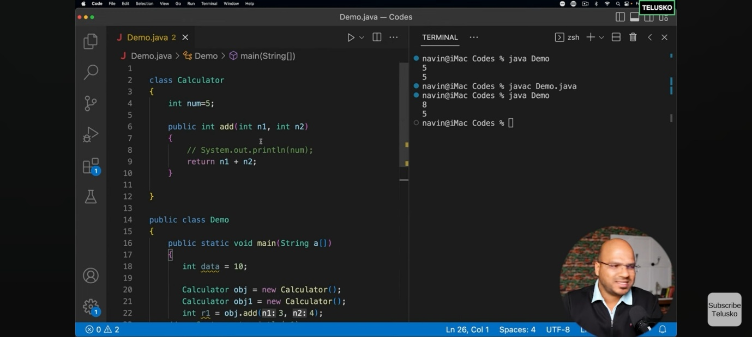

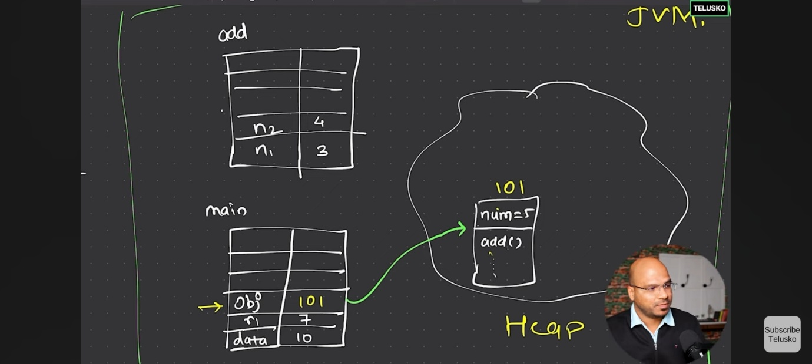

**>>How Main method works:** In Java, the main class (the class containing the `main` method) serves as the entry point for the application. When you run a Java application, the Java Virtual Machine (JVM) starts executing the `main` method without explicitly creating an instance of the main class. Here’s how memory management works in this context:

1. **Static Context**: The `main` method is `static`, meaning it belongs to the class itself rather than an instance of the class. Static methods and variables are stored in a special area of memory known as the **method area** (part of the heap in many JVM implementations).
2. **Method Area**: The method area stores class-level data, including static variables, method definitions (including the `main` method), and other class-level structures. When the JVM loads the main class, it allocates memory for these static members in the method area.
3. **Stack Memory**: When the JVM starts executing the `main` method, it creates a stack frame for it in the **stack memory**. The stack is used for method execution, including local variables and method call management. Each thread has its own stack.
4. **Heap Memory**: If the `main` method or any other part of the program creates objects using the `new` keyword, these objects are allocated memory in the **heap**. The heap is shared among all threads and is managed by the JVM’s garbage collector, which reclaims memory from objects that are no longer reachable.

To summarize, the `main` method and any other static members of the main class reside in the method area, while objects created during the execution of the program are stored in the heap. Local variables within the `main` method (or any other method) are stored in the stack. This division of memory areas helps in efficient memory management and execution of Java programs.

**>>**

**Instances Variables vs Other Variables:**

Instance variables in Java differ from other types of variables in several key ways:

1. **Scope and Lifetime**:

- **Instance Variables**: These are defined within a class but outside any method, constructor, or block. They are created when an object of the class is instantiated and destroyed when the object is destroyed. Each object has its own copy of instance variables.

- **Local Variables**: These are defined within a method, constructor, or block. They are created when the method, constructor, or block is entered and destroyed once it exits. They are not accessible outside their defining method, constructor, or block.

- **Static Variables**: Also known as class variables, these are defined within a class using the `static` keyword but outside any method, constructor, or block. There is only one copy of a static variable, regardless of how many objects of the class are created. They are associated with the class itself rather than any specific instance.

2. **Memory Location**:

- **Instance Variables**: Stored in the heap, as part of the object.

- **Local Variables**: Stored in the stack, as part of the stack frame for the method, constructor, or block in which they are defined.

- **Static Variables**: Stored in the method area (part of the heap in many JVM implementations), shared among all instances of the class.

3. **Default Values**:

- **Instance Variables**: Automatically initialized to default values (e.g., `0` for integers, `null` for object references) if not explicitly initialized.

- **Local Variables**: Must be explicitly initialized before use; they do not get default values.

- **Static Variables**: Automatically initialized to default values if not explicitly initialized.

4. **Access Modifiers**:

- **Instance Variables**: Can be marked with access modifiers (`private`, `protected`, `public`) to control their visibility.

- **Local Variables**: Cannot have access modifiers; their scope is limited to the method, constructor, or block in which they are declared.

- **Static Variables**: Can also be marked with access modifiers and are accessed using the class name.

5. **Use Case**:

- **Instance Variables**: Hold the state of an object. Different objects can have different values for their instance variables.

- **Local Variables**: Used for temporary storage of data within a method, constructor, or block.

- **Static Variables**: Used for values shared among all instances of a class, such as constants or counters. Here is a quick example to illustrate the differences:

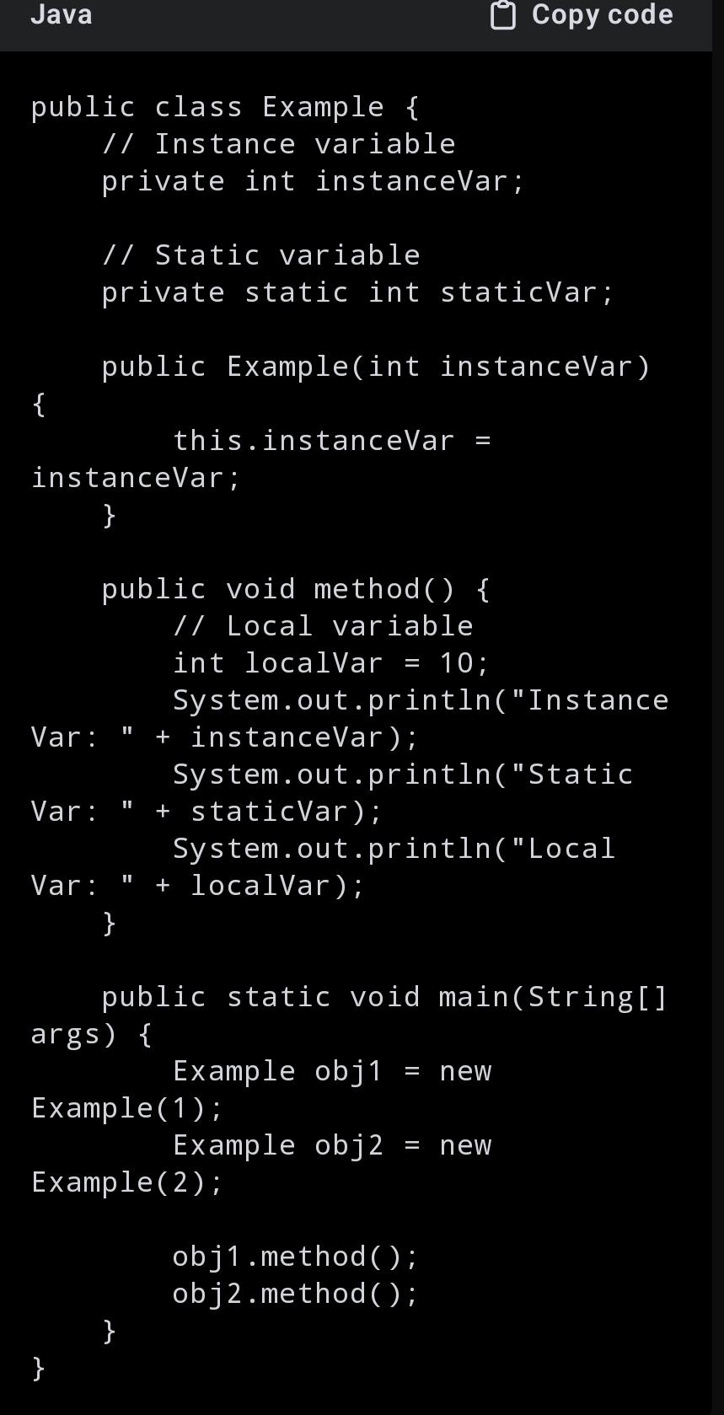

In this example:

- `instanceVar` is an instance variable, so each `Example` object has its own copy.

- `staticVar` is a static variable, shared among all `Example` objects.

- `localVar` is a local variable, accessible only within the `method`.

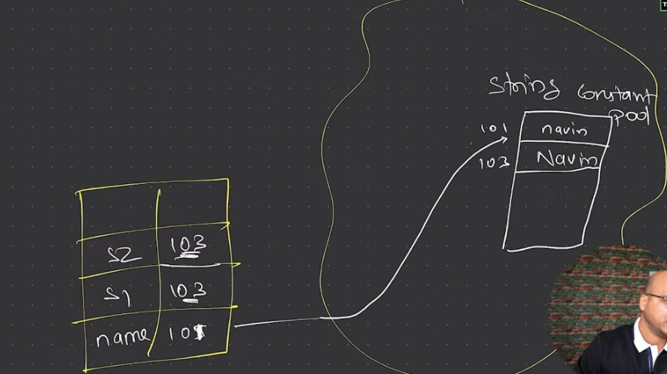

**>>**Class.forName("<classname>") is to load the class

**>>**The static keyword in Java is used to define class-level variables and methods, meaning they belong to the class itself rather than any specific instance of the class. This has multiple uses and benefits. First, static variables are shared among all instances of a class, ensuring there is only one copy of the variable, which helps in saving memory and maintaining consistency across all instances. For example, a static counter variable can track the number of objects created, accessible and modifiable by all instances. Second, static methods can be called directly using the class name without needing to create an object. This is particularly useful for utility or helper methods that perform tasks not dependent on instance-specific data, such as mathematical calculations or configuration settings. Additionally, static blocks allow for static initialization, which runs once when the class is loaded, enabling the setup of static variables. Overall, the static keyword enhances memory efficiency, simplifies access to common methods and variables, and ensures consistent state management across all instances of a class.

**>>**The heap is divided into generations (Young Generation, Old Generation) to optimize garbage collection.The Young Generation is collected frequently because it contains many short-lived objects.The Old Generation is collected less frequently but can still undergo garbage collection when it fills up.

**>>**The method area in the Java Virtual Machine (JVM) is a part of the JVM's memory where class-level structures are stored. It serves several key purposes in managing Java programs:  
  
1. Class Metadata:   
   - When a class is loaded by the JVM, its metadata (information about the class such as its name, modifiers, superclass, interfaces, etc.) is stored in the method area.  
     
2. Static Fields:   
   - Static variables declared within a class are stored in the method area. These variables are shared among all instances of the class.  
  
3. Method Data:   
   - The method area contains information about methods and constructors of classes, including bytecode (compiled code of methods).

4. Constant Pool:   
   - Each class loaded by the JVM has a runtime constant pool, which is part of the method area. This pool contains constants, literals, and symbolic references used within the class.  
  
5. Memory Management:   
   - The method area is managed by the JVM's memory manager, and while it supports garbage collection, it typically collects less frequently compared to the heap.  
  
6. Shared among Threads:   
   - The method area is shared among all threads running within the JVM. This shared access ensures consistency in class data and method execution across the application.  
  
Overall, the method area plays a crucial role in storing and managing class-related information and static variables, supporting the execution and management of Java programs within the JVM.

**>>this** keyword is a reference to the current instance of the class in which it is used. this reference is not created in memory in the same way that objects and variables are. Instead, it is a logical construct provided by the Java compiler that exists as part of the method or constructor's context. When an object is created using the new keyword, the object itself is allocated in the heap memory. The **this** reference is implicitly passed to instance methods and constructors as a hidden parameter.

**>>**If you call a method from a constructor that is overridden in a subclass, the method from the subclass will be called.

**Reason**:

Dynamic Method Dispatch:

In Java, non-static methods are by default virtual, meaning the method that gets executed is determined at runtime based on the actual object's type, not the reference type. This is called dynamic method dispatch or late binding.When an object is being created, the constructor of the class and its parent classes are executed in a specific order. If a method call occurs in a constructor, the virtual method mechanism looks up the method in the runtime type of the object being created, not the type where the constructor is defined.

Object Creation Process:

When a subclass object is created, Java first initializes the superclass part of the object by calling the superclass constructor. If the superclass constructor calls an overridden method, Java calls the overridden method in the subclass

**>>**In Java, when you create an object of a subclass, the constructor of the superclass is automatically called. This happens because of the way object initialization works in Java, ensuring that the entire object is fully initialized, including the parts inherited from any superclasses. Here’s a detailed explanation:

Implicit Constructor Call:

When you instantiate a subclass, Java implicitly calls the constructor of its superclass before executing the subclass constructor.This ensures that the inherited fields and methods from the superclass are properly initialized before the subclass's own initialization code runs.

Constructor Chaining:

Constructor chaining refers to the process where a constructor calls another constructor, either in the same class or in the superclass. In Java, if a constructor does not explicitly call another constructor using this() (for the same class) or super() (for the superclass), the compiler automatically inserts a call to the no-argument constructor of the superclass as the first line of the constructor.

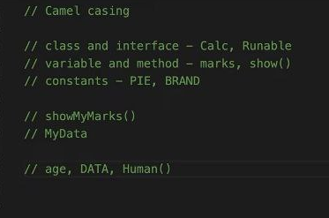

**>>**

Advantages of Using List Reference while creating a ArrayList object:

Flexibility:

If you use a List reference, you can easily change the implementation to another List type (e.g., LinkedList) without changing the code that uses the List.List<String> list = new LinkedList<>();

Abstraction:

Using interfaces promotes abstraction, making your code more modular and easier to maintain. You can work with higher-level concepts (like a list) rather than specific implementations.

Code Reusability:Code that uses the List interface can work with any implementation of List, increasing code reusability and reducing coupling.

Easier Testing: Using interfaces makes it easier to substitute different implementations during testing, which can be useful for unit tests.

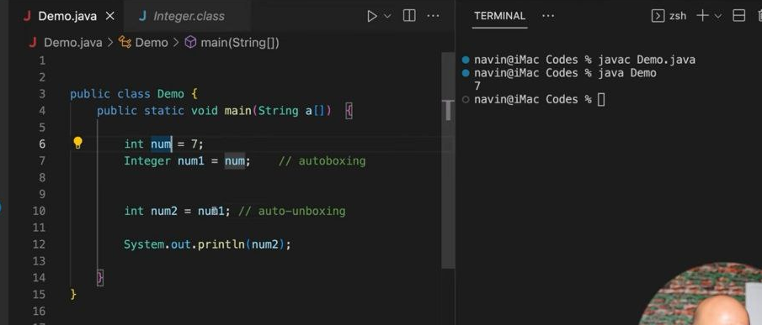

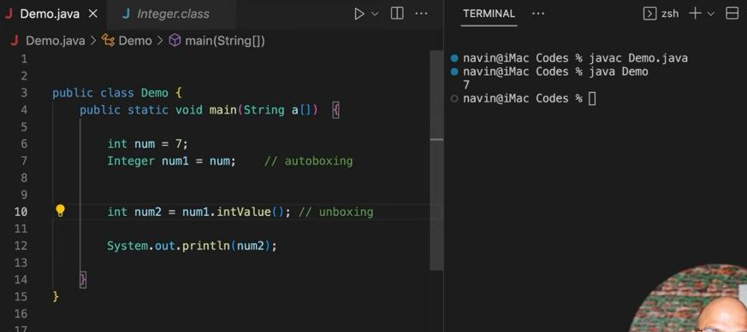

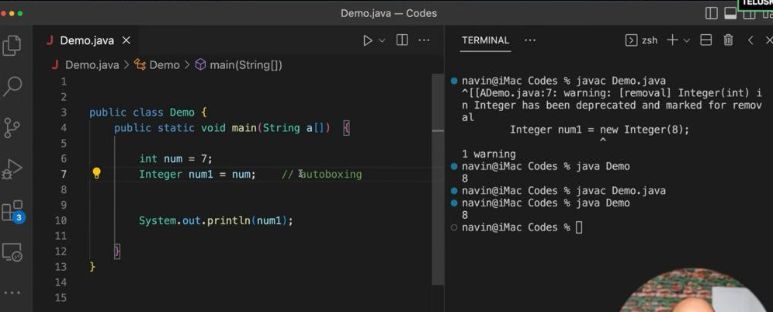

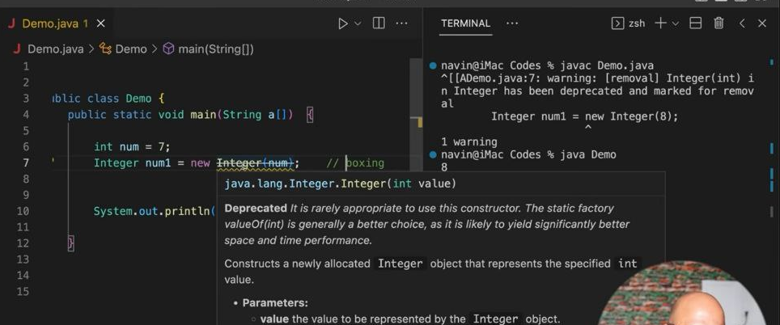

### Boxing

Boxing is the process of converting a primitive type into its corresponding wrapper class object. This is done manually before Java 5.

Example:

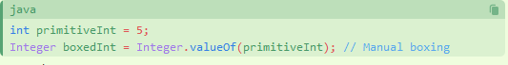

### Unboxing

Unboxing is the reverse process, where a wrapper class object is converted back to its corresponding primitive type.

Example:

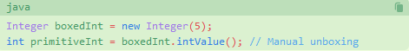

### Auto-boxing

Auto-boxing is the automatic conversion that the Java compiler makes between the primitive types and their corresponding object wrapper classes. This feature was introduced in Java 5.

Example:

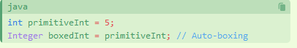

### Auto-unboxing

Auto-unboxing is the automatic conversion that the Java compiler makes from the wrapper class to the primitive type.

Example:

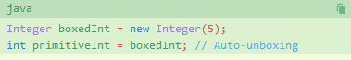

**>>**

In Java, you cannot override a variable, but you can hide it. Variable hiding occurs when a subclass declares a variable with the same name as a variable in its superclass. The variable in the superclass is hidden, not overridden, by the variable in the subclass

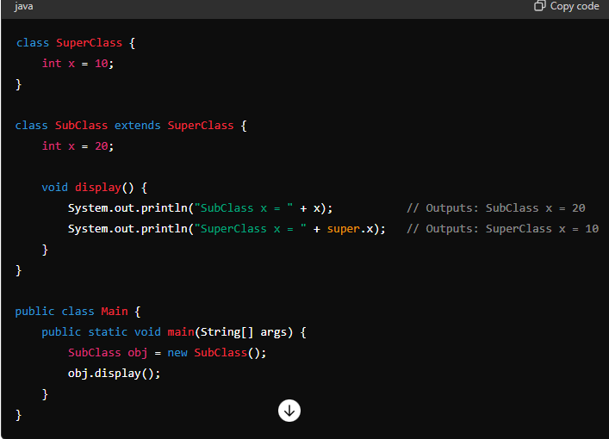

**>>**concrete class is the child class of abstract class which have all the implementation of abstract methods of abstract class

**>>** more on casting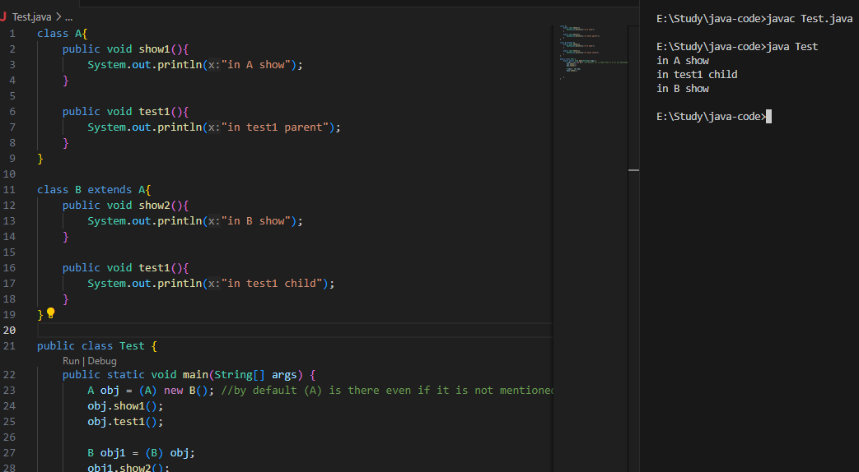

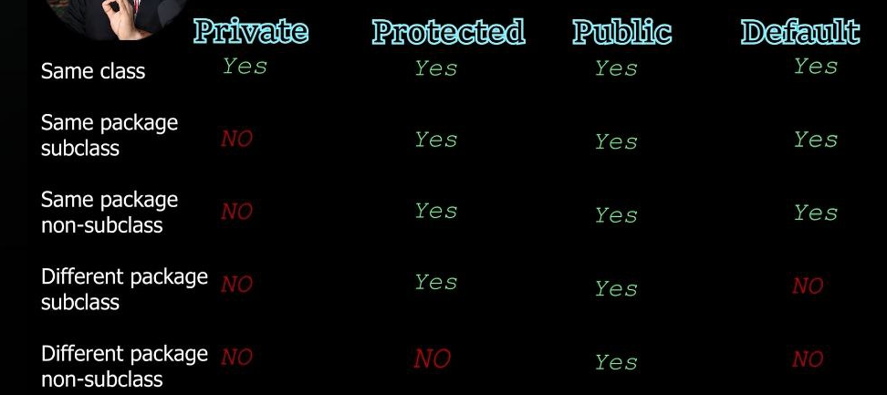

>>Inner Class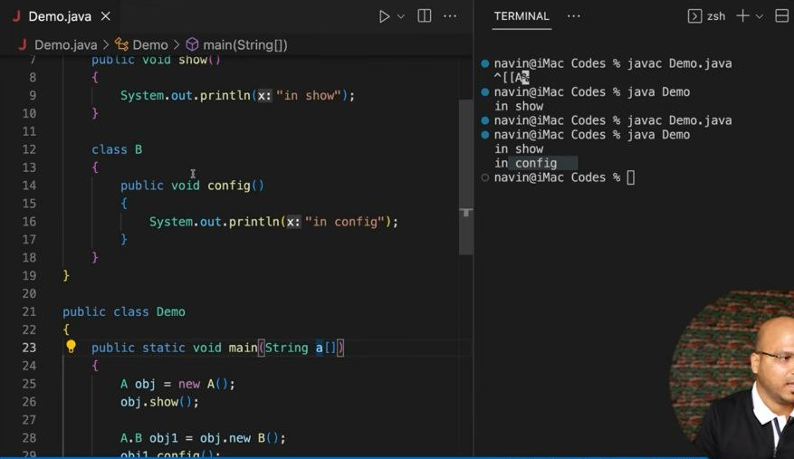

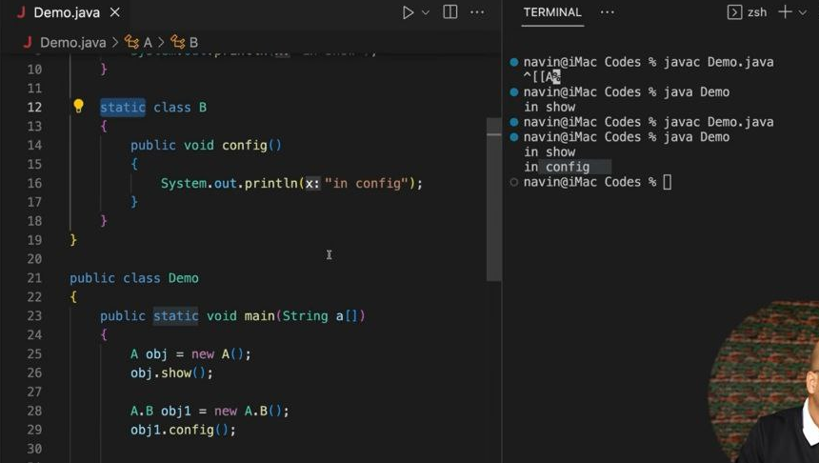

**>>Anonymous** object

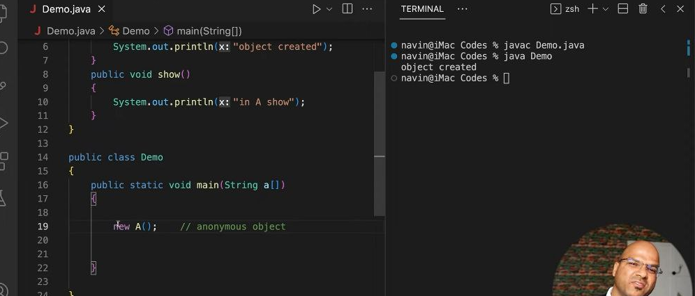

**>>**anonymous class/anonymous inner class

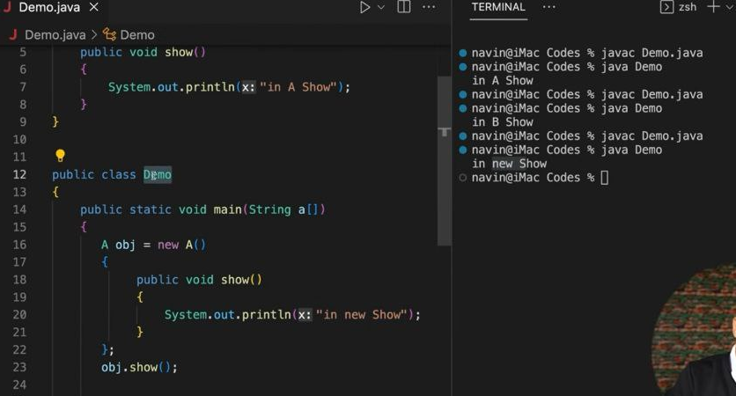

**>>**Anonymous inner class for an abstract class

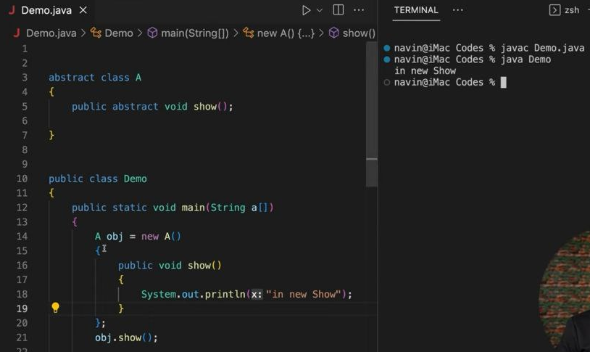

**>>**interface can have variables. those are by default static and final

**>>** If you want to prove that the default constructor is getting invoked without explicitly adding any print statements in the constructor, you can demonstrate it indirectly by observing the initialization behavior of instance variables. Constructor is responsible for initialization of the instance variables

**>>** A functional interface in Java is an interface that contains exactly one abstract method. These interfaces can have any number of default or static methods. Functional interfaces are used as the basis for lambda expressions and method references, which provide a clear and concise way to represent single-method interfaces using an expression

**>>lambda expression**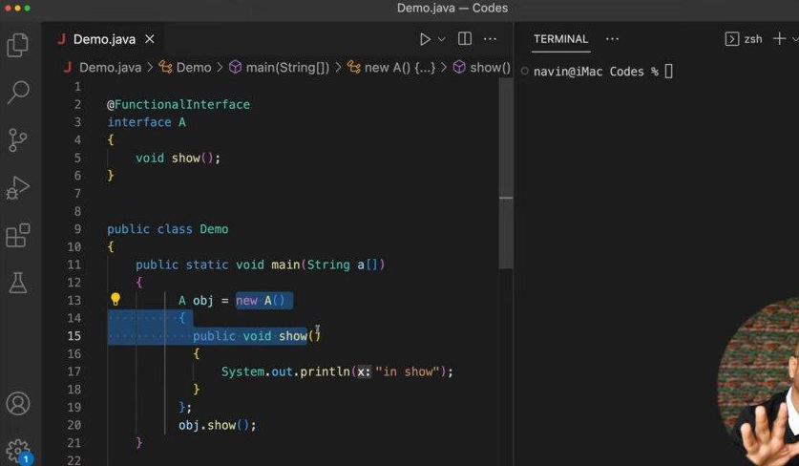

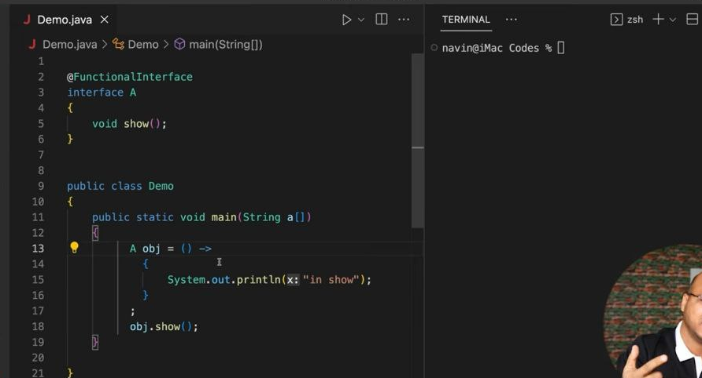

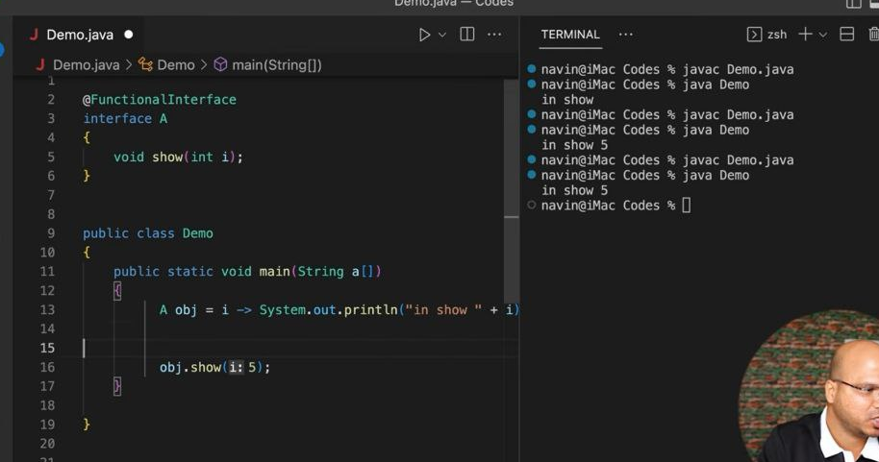

only one statement so we don't need to write return

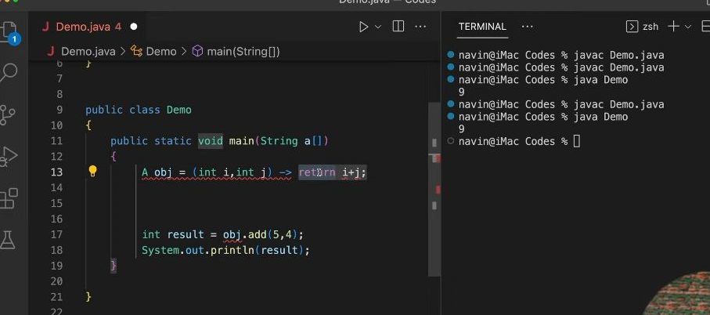

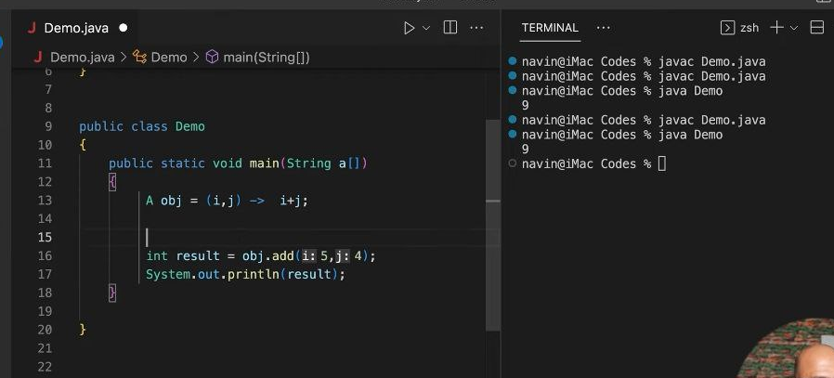

**>>Types of interface**

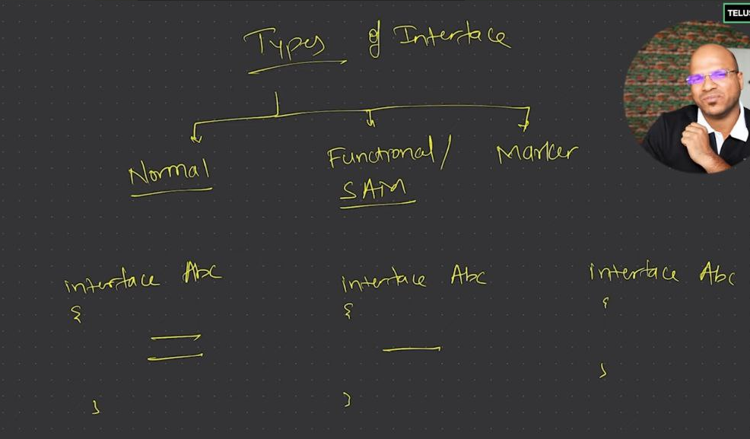

A marker interface in Java is an interface that does not contain any methods or fields. Its primary purpose is to mark or tag a class with a specific capability or property. This tagging can be used by the Java runtime or other frameworks to provide special behavior to the marked classes.

Common examples of marker interfaces in Java include:

1. Serializable: Used to indicate that a class can be serialized (converted into a byte stream) so that its objects can be saved to a file or transmitted over a network.

2. Cloneable: Indicates that a class allows for a field-for-field copy of instances using the clone method.

3. Remote: Marks a class as a remote object for Java RMI (Remote Method Invocation).

### How Marker Interfaces Work

Marker interfaces work by relying on runtime checks or framework-specific logic that looks for the presence of the marker interface to determine if special handling is required. For example, the Java serialization mechanism checks if a class implements Serializable to decide whether it can serialize the object's state.

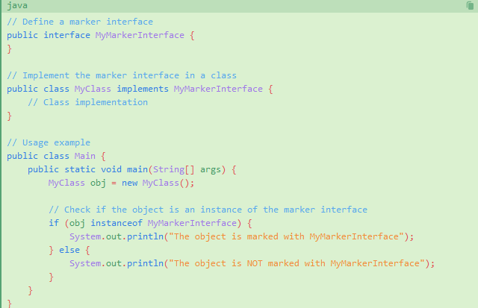

### Serializable

- Purpose: Indicates that a class can be serialized, meaning its instances can be converted into a byte stream and later restored.

- Use Case: Object serialization for saving object state to a file, sending objects over a network, or storing them in a database.

- Example:

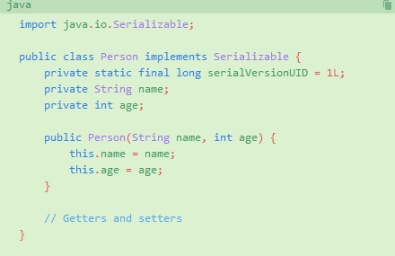

### Cloneable

- Purpose: Indicates that a class allows for a field-for-field copy of its instances through the clone() method.

- Use Case: Creating a duplicate object with the same state.

- Example:

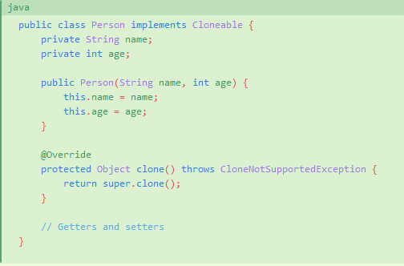

### Remote

- Purpose: Indicates that a class can be used to create remote objects in Java RMI (Remote Method Invocation).

- Use Case: Defining objects whose methods can be called from another JVM.

- Example:

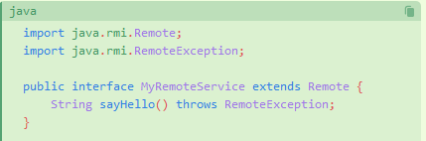

**>>Exception**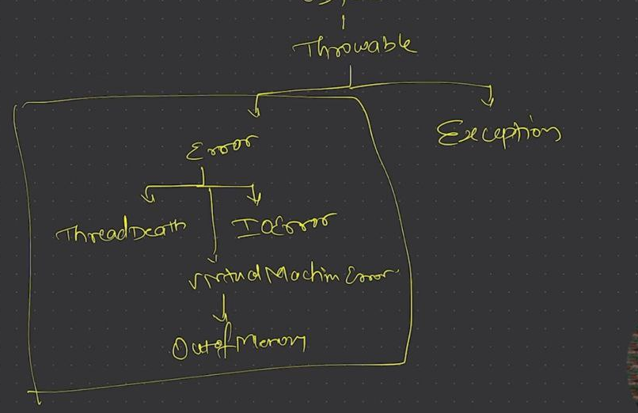

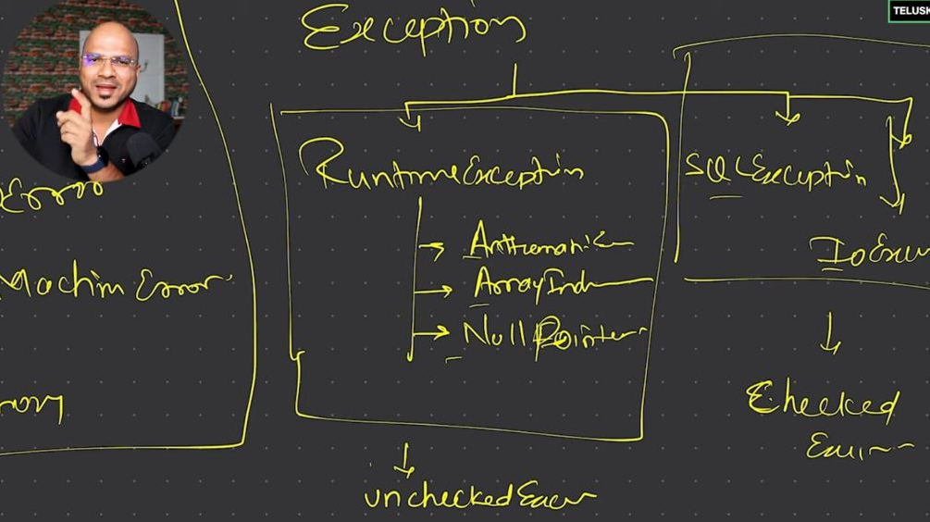

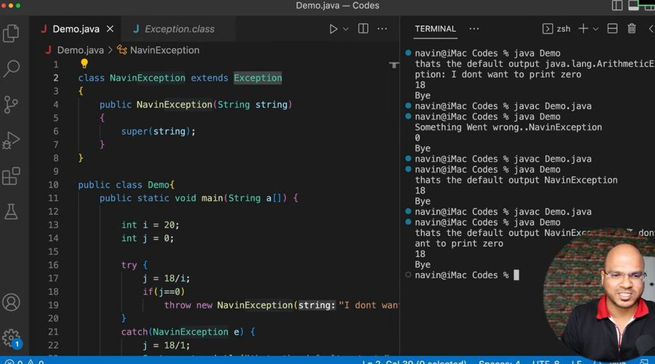

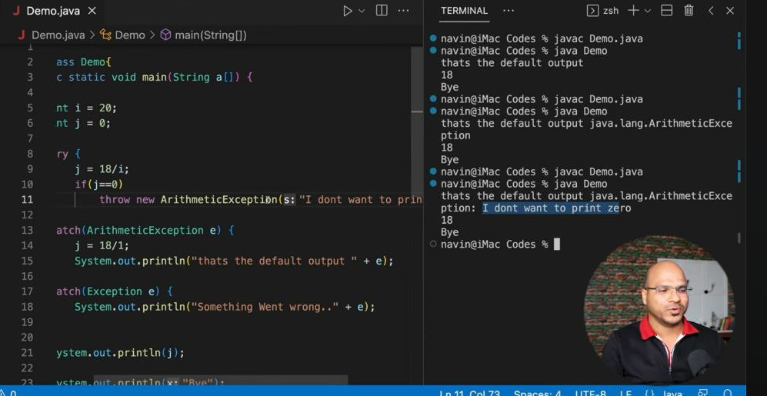

**>>Finally keyword**

The finally keyword in Java is used in conjunction with a try block to ensure that a block of code is always executed, regardless of whether an exception is thrown or caught. This is particularly useful for cleanup activities like closing files, releasing resources, or other important finalization tasks.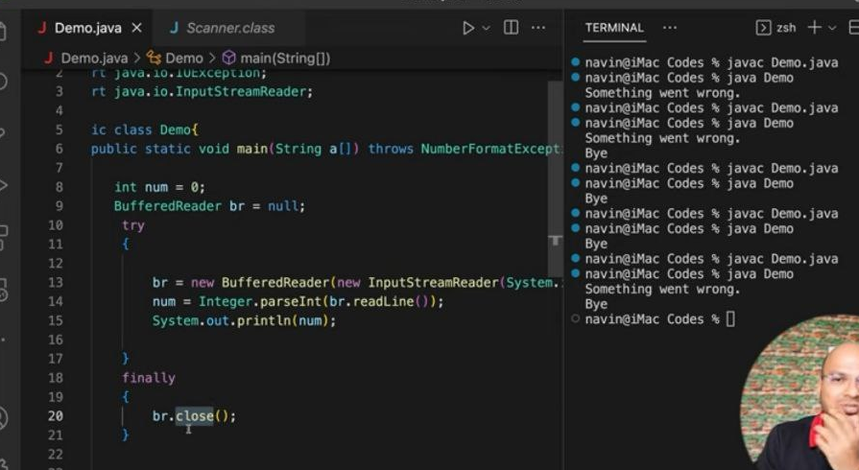

**>>Tread**

In Java, a thread is a lightweight process that allows concurrent execution of two or more parts of a program for maximum utilization of CPU. Threads can be used to perform complicated tasks in the background without interrupting the main program.

Java provides two ways to create a thread:

1. **Extending the Thread class**: You can create a new class that extends Thread and override its run method. Then, create an instance of this class and call its start method to begin execution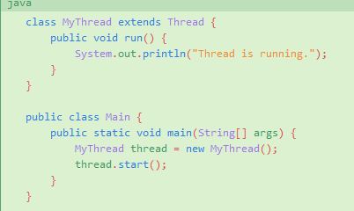

2. **Implementing the Runnable interface**: You can create a class that implements the Runnable interface and pass an instance of this class to a Thread object, then call the start method.

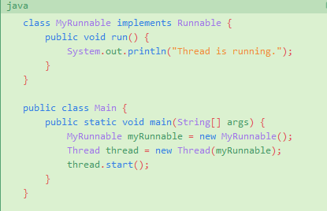

Key methods associated with threads include:

- start(): Starts the execution of the thread.

- run(): Contains the code that constitutes the new thread.

- sleep(long millis): Causes the thread to sleep for a specified number of milliseconds.

- join(): Waits for the thread to die.

- interrupt(): Interrupts the thread.

Using threads can improve the performance of a Java application by allowing multiple operations to run concurrently. However, it also introduces complexity, particularly with issues related to synchronization and shared resources

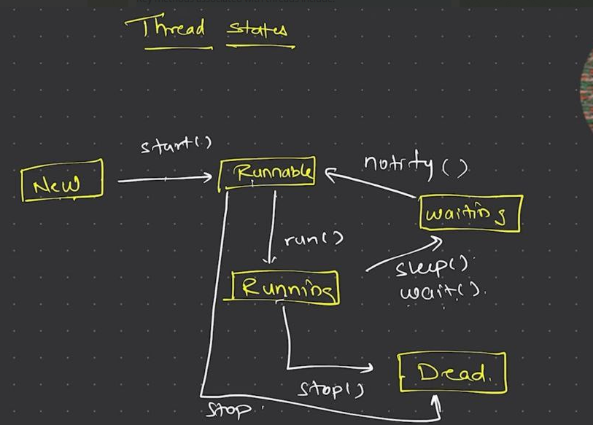

**>>**

TreeSet is a class in Java that implements the Set interface and uses a TreeMap to store its elements. It provides an ordered set backed by a balanced tree, meaning the elements are sorted according to their natural ordering or by a specified comparator. Here are some key characteristics and features of TreeSet:

1. **Sorted Order**: Elements are sorted in ascending order by default. You can also provide a custom comparator to define the order.
2. **No Duplicates**: As with any Set, TreeSet does not allow duplicate elements.
3. **NavigableSet Implementation**: TreeSet implements the NavigableSet interface, which provides methods for navigation (e.g., lower(), floor(), ceiling(), higher()).

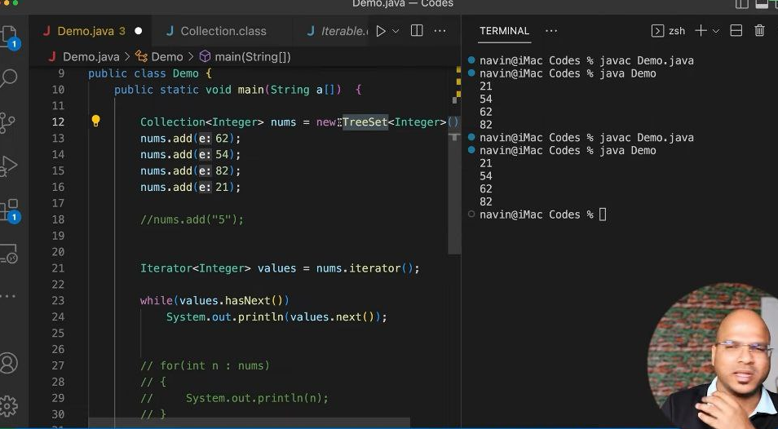

**>> HaspSet and HashMap**

In Java, both HashSet and HashMap do not allow duplicate values, but they handle it in different ways due to their internal structure and design.

### HashSet:

- Internal Structure: HashSet is backed by a HashMap instance. Essentially, it uses a HashMap to store its elements.

- Storage Mechanism: Each element in a HashSet is stored as a key in the underlying HashMap, with a constant dummy value (like Boolean.TRUE).

- Memory Management: When you add an element to a HashSet, it checks if the HashMap already contains the key. If the key exists, it does not add the duplicate key. This lookup operation is generally O(1) due to hashing. This is efficient in terms of memory management because it prevents the storage of duplicate values by leveraging the HashMap's key uniqueness.

### HashMap:

- Internal Structure: HashMap consists of an array of buckets. Each bucket is essentially a linked list (or a balanced tree if the list becomes too long) of Entry objects. Each Entry object contains a key, a value, a hash value, and a pointer to the next Entry.

- Storage Mechanism: When you add a key-value pair to a HashMap, the hash value of the key is calculated and used to determine the appropriate bucket. If the bucket is empty, the Entry is placed there. If not, it checks the linked list for the presence of the key.

- Memory Management: For a key-value pair, the key is stored uniquely. If you attempt to add a key that already exists, the HashMap replaces the old value with the new value but does not store the key again. This ensures no duplicate keys exist, optimizing memory usage.

**>>Memories**

In Java, memory is primarily divided into two main areas: the heap and the stack. Here's a breakdown of what is stored in each:

1. Heap Memory:

- Objects: All objects in Java are stored in the heap.

- Instance Variables: The fields defined inside a class and stored within the objects.

- JVM Runtime Constant Pool: Part of the method area that stores constants.

2. Stack Memory:

- Primitive Local Variables: Variables of primitive data types (e.g., int, char) declared inside methods.

- Reference Variables: Variables that hold references to objects in the heap.

- Method Calls: Each method call creates a new frame in the stack, storing local variables, method arguments, and the return address.

3. Other Memory Areas:

- Method Area (or Permanent Generation / Metaspace): Stores class-level data, such as class definitions, static variables, and method bytecode. In Java 8 and later, the Metaspace replaces the Permanent Generation.

- PC Registers: Each thread has its own PC (Program Counter) register, which keeps track of the JVM instruction being executed.

- Native Method Stacks: Used for native (non-Java) method calls.

Understanding the distinction between these memory areas is crucial for optimizing memory usage and performance in Java applications.

**>>HashMap and HashTable**

HashMap and Hashtable are both implementations of the Map interface in Java, but they have several key differences:

### HashMap

1. Synchronization: HashMap is not synchronized, meaning it is not thread-safe. If multiple threads access a HashMap concurrently and at least one of the threads modifies it, external synchronization is necessary.

2. Performance: Because it is not synchronized, HashMap is faster than Hashtable for non-thread-safe operations.

3. Null Keys and Values: HashMap allows one null key and multiple null values.

4. Iterator: The iterator of HashMap is fail-fast, which means that if the map is structurally modified after the iterator is created, it will throw a ConcurrentModificationException.

### Hashtable

1. Synchronization: Hashtable is synchronized, making it thread-safe. All methods in Hashtable are synchronized, which ensures thread safety.

2. Performance: Because of its synchronized methods, Hashtable is generally slower than HashMap.

3. Null Keys and Values: Hashtable does not allow any null key or value. If a null key or value is used, it throws a NullPointerException.

4. Iterator: The enumerator for Hashtable is not fail-fast.

**>> Collection vs Collections vs the Collection API**

In Java, Collection, Collections, and the Collection API are related but distinct concepts. Here's an overview of each:

### Collection API

- Definition: The Collection API is a framework provided by Java that defines several classes and interfaces for managing groups of objects as a single unit. This includes various interfaces, implementations, and utility methods for data structures like lists, sets, and maps.

- Components:

- Interfaces: Collection, List, Set, Queue, Map, etc.

- Implementations: ArrayList, LinkedList, HashSet, TreeSet, HashMap, TreeMap, etc.

- Utility Classes: Collections, Arrays, etc.

### Collection

- Definition: Collection is the root interface in the Collection hierarchy. It represents a group of objects, known as elements. The Collection interface is part of the Java Collection API.

- Key Methods:

- add()

- remove()

- size()

- iterator()

- clear()

- Subinterfaces: List, Set, Queue (which all extend Collection).

### Collections

- Definition: Collections is a utility class in the Java Collection API. It consists exclusively of static methods that operate on or return collections. It cannot be instantiated.

- Purpose: Provides methods for:

- Sorting (sort())

- Searching (binarySearch())

- Thread-safety (synchronizedCollection(), synchronizedList())

- Immutability (unmodifiableCollection(), unmodifiableList())

- Other utility operations (reverse(), shuffle(), min(), max())

### Summary

- Collection API: The overall framework that includes interfaces, implementations, and utility methods for working with collections of objects.

- Collection: The root interface that represents a group of objects. It is extended by more specific subinterfaces like List, Set, and Queue.

- Collections: A utility class with static methods to manipulate and return collections. It provides algorithms and methods for common operations like sorting, searching, and making collections thread-safe or immutable.

**>> Comparable and Comparator**

### **Comparable**

1. Interface Definition: Comparable<T>

2. Purpose: Defines the natural ordering of objects. It allows an object to compare itself with another object of the same type.

3. Method: compareTo(T o)

- Signature: int compareTo(T o)

- Description: Compares the current object with the specified object for order. Returns a negative integer, zero, or a positive integer as this object is less than, equal to, or greater than the specified object.

4. Usage: Implemented by the class whose instances need to be compared. 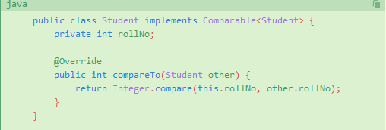

5. Default Sorting: When using sorting methods (like Collections.sort()), if a class implements Comparable, its compareTo() method is used for ordering

### **Comparator**

1. Interface Definition: Comparator<T>

2. Purpose: Defines a custom ordering of objects. It allows a class to compare two other objects.

3. Methods:

- compare(T o1, T o2)

- Signature: int compare(T o1, T o2)

- Description: Compares its two arguments for order. Returns a negative integer, zero, or a positive integer as the first argument is less than, equal to, or greater than the second.

- reversed(), thenComparing(), and other default and static methods for chaining and composing comparators.

4. Usage: Implemented by a separate class or used as an anonymous class or lambda expression.

Example:

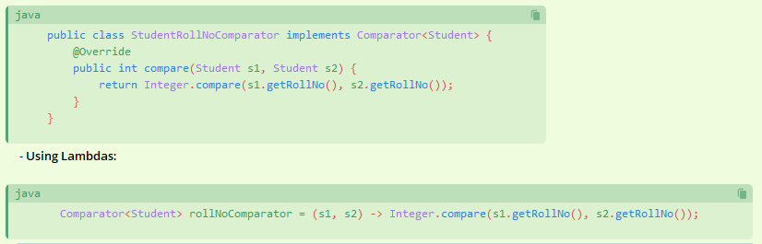

Custom Sorting: When using sorting methods (like Collections.sort()), you can pass an instance of Comparator to define the custom order.

- Example:

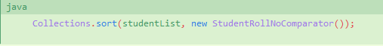

### Summary

- Comparable:

- Used for natural ordering.

- Implemented by the class itself.

- Has a single method compareTo().

- Comparator:

- Used for custom ordering.

- Implemented by a separate class or using lambdas.

- Has a method compare().

- More flexible and can define multiple sorting sequences.

In practice, use Comparable when objects have a natural order and Comparator when you need multiple ways to compare objects or do not control the source code of the class being compared.

**>>varargs**

In Java, the term varargs refers to a feature that allows a method to accept a variable number of arguments. This is achieved using the ellipsis (...) syntax. The method can then handle these arguments as an array. Varargs provide a convenient way to pass a variable number of arguments of the same type to a method without needing to define multiple overloaded methods.

** Within the method, the varargs parameter is treated as an array of the specified type.

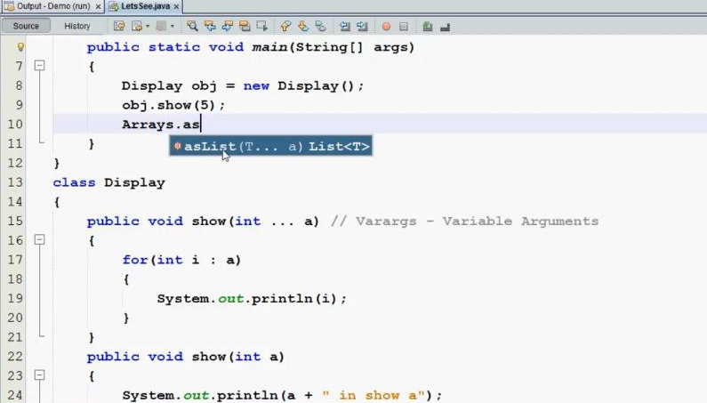

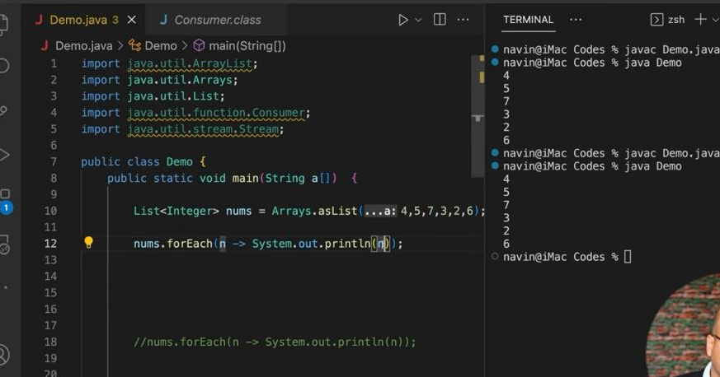

**>>Stream**

A stream represents an ordered sequence of data that can be read from or written to. Streams are a fundamental concept for performing input and output (I/O) operations in Java, enabling the reading and writing of data from different sources like files, network connections, and memory.

### Types of Streams in Java

#### Byte Streams

Byte streams handle I/O of raw binary data. They read and write data in bytes and are suitable for handling binary files like images and audio files.

- InputStream: An abstract class representing an input stream of bytes. Common subclasses include:

- FileInputStream

- BufferedInputStream

- DataInputStream

- OutputStream: An abstract class representing an output stream of bytes. Common subclasses include:

- FileOutputStream

- BufferedOutputStream

- DataOutputStream

#### Character Streams

Character streams handle I/O of character data. They read and write data in characters (16-bit Unicode). These streams are suitable for handling text files.

- Reader: An abstract class representing a character input stream. Common subclasses include:

- FileReader

- BufferedReader

- InputStreamReader

- Writer: An abstract class representing a character output stream. Common subclasses include:

- FileWriter

- BufferedWriter

- OutputStreamWriter

### Buffered Streams

Buffered streams use an internal buffer to read or write data in larger chunks, which can improve I/O performance by reducing the number of I/OBufferedInputStreamredInBufferedOutputStreamedOutputStream** for BufferedReaderBuffeBufferedWriterBufferedWriter** for character streams

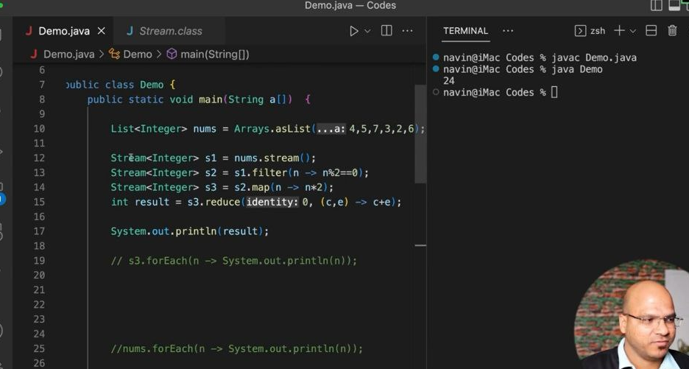

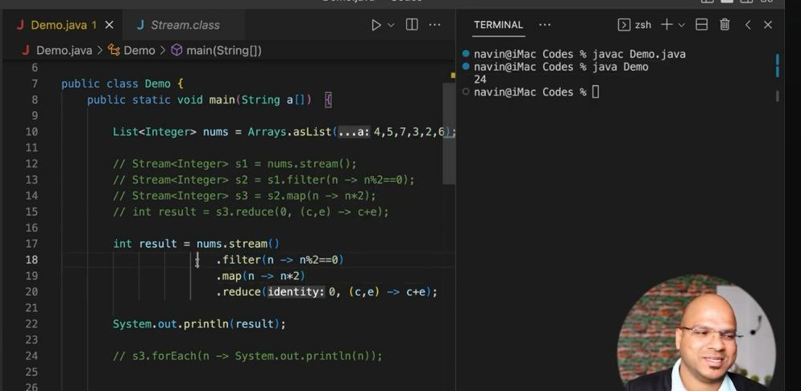

**>>sealed class**

In Java, the sealed keyword is used to define a class or interface that restricts which other classes or interfaces can extend or implement it. This feature, introduced in Java 15 as a preview and finalized in Java 17, helps to provide more control over the inheritance hierarchy, allowing for better maintainability and security.

### Key Concepts of Sealed Classes

1. **Sealed Class**: A class that restricts which other classes can extend it.
2. **Permitted Subclasses**: Only classes explicitly specified in the sealed class declaration can extend the sealed class.
3. **Non-sealed Classes**: A subclass that is allowed to be extended by other classes without restriction.
4. **Final Classes**: A subclass that cannot be further extended.
5. **Abstract Classes**: A subclass that can be extended but must be specified as permitted.

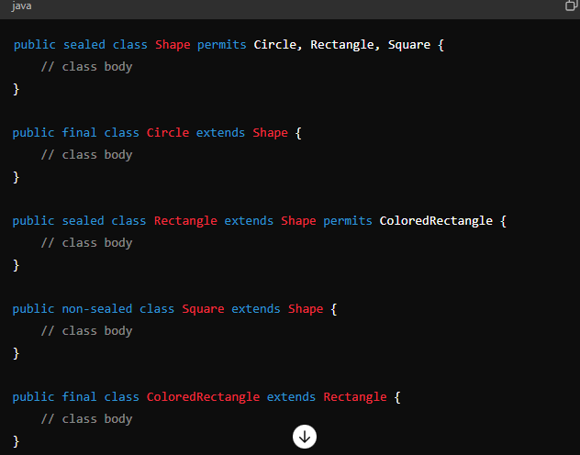

**>>** Non-static variables (instance variables) can't be accessed inside static methods because static methods belong to the class itself, not to any instance of the class. Instance variables are tied to specific objects of the class, and since static methods don't have a reference to any specific object, they can't directly access these variables. To access instance variables within a static method, you must pass an instance of the class to the method and use that instance to access the variables.

**>>Object cloning**

Object cloning in Java refers to creating a duplicate or exact copy of an existing object. This process allows you to replicate an object's state and behavior without requiring the same initial setup or data retrieval operations that were used to create the original object. Cloning can be achieved in Java using either the Cloneable interface or by implementing the Cloneable interface and overriding the clone() method.

### Using Cloneable Interface

1. **Implementing Cloneable**:

- Cloneable is a marker interface (contains no methods) that indicates the class allows its instances to be cloned.

2. **Overriding clone() Method**:

- The clone() method is defined in the Object class with the protected access level. To use it, you must override it with public access level in your claDeep vs Shallow Cloningloning*Shallow cloningloning**: By default, clone() performs a shallow copy, copying all fields of the object. If fields are primitive types, they are copied directly. If fields are reference types, the references are copied (not the objects themselvesDeep cloningloning**: If the object contains reference fields that need to be deeply copied (i.e., copies of referenced objects are also created), you need to override clone() to achieve this.

### Example of Object Cloning

|  |
| --- |
|  |

**>>** **Example of Deep copy using Clonable:**

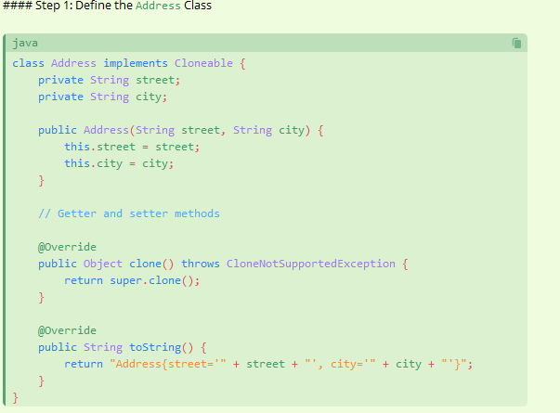

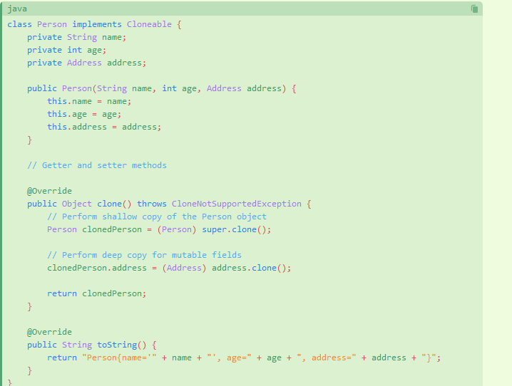

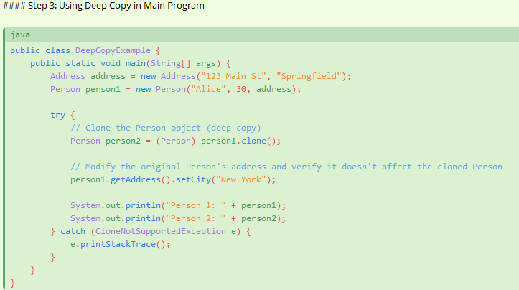

### Core Classes

1. Object (Class)

- Description: The root class of the Java class hierarchy. Every class has Object as a superclass. It provides methods such as equals(), hashCode(), toString(), clone(), and wait()/notify() for thread synchronization.

2. String (Class)

- Description: Represents a sequence of characters. Strings are immutable in Java, meaning their values cannot be changed once created.

3. Math (Class)

- Description: Provides methods for performing basic numeric operations such as exponentiation, logarithms, square roots, and trigonometric functions.

4. System (Class)

- Description: Provides access to system-related functionality such as standard input/output streams, environment variables, and system properties.

5. Thread (Class)

- Description: Represents a thread of execution in a Java program. Threads allow concurrent execution of code.

6. Exception (Class)

- Description: The superclass of all exceptions that can be thrown by the Java Virtual Machine (JVM). Provides mechanisms for error handling in Java.

### Collection Framework

1. List<E> (Interface)

- Description: An ordered collection (also known as a sequence) that allows duplicate elements. Common implementations include ArrayList and LinkedList.

2. Set<E> (Interface)

- Description: A collection that does not allow duplicate elements. Common implementations include HashSet, LinkedHashSet, and TreeSet.

3. Map<K, V> (Interface)

- Description: An object that maps keys to values. A map cannot contain duplicate keys. Common implementations include HashMap, LinkedHashMap, and TreeMap.

4. Queue<E> (Interface)

- Description: A collection designed for holding elements prior to processing. Common implementations include LinkedList and PriorityQueue.

5. Iterator<E> (Interface)

- Description: An interface that provides methods to iterate over a collection.

### I/O (Input/Output)

1. File (Class)

- Description: Represents a file or directory path in the filesystem.

2. InputStream / OutputStream (Class)

- Description: Abstract classes that represent input and output streams of bytes. Common subclasses include FileInputStream, FileOutputStream, and BufferedInputStream.

3. Reader / Writer (Class)

- Description: Abstract classes for reading and writing character streams. Common subclasses include FileReader, FileWriter, BufferedReader, and BufferedWriter.

### Concurrency

1. Runnable (Interface)

- Description: Represents a task that can be executed concurrently by a thread. Implemented by classes that define a single method, run().

2. Callable<V> (Interface)

- Description: Similar to Runnable, but can return a result and throw a checked exception. Defines a single method, call().

3. ExecutorService (Interface)

- Description: Provides methods for managing the execution of asynchronous tasks.

4. CompletableFuture (Class)

- Description: Represents a future result of an asynchronous computation, and provides methods to handle the result once it becomes available.

### Networking

1. Socket (Class)

- Description: Provides the means to establish a connection between a client and a server.

2. ServerSocket (Class)

- Description: Used by servers to listen for incoming connections.

3. URL (Class)

- Description: Represents a Uniform Resource Locator, a pointer to a "resource" on the World Wide Web.